**Hot Packs Used in Physical Therapy**

By [Laura Inverarity, DO](https://www.verywellhealth.com/laura-inverarity-do-2695989)

Updated on June 07, 2022

 Medically reviewed by [Oluseun Olufade, MD](https://www.verywellhealth.com/oluseun-olufade-md-5183759)

Hot packs are a type of [physical modality](https://www.verywellhealth.com/physical-therapy-treatments-and-modalities-2696683) often used in [physical therapy](https://www.verywellhealth.com/physical-therapy-4014670) clinics. They are applied to your injured body part by your physical therapist (PT). Physical therapists wrap moist hot packs in several layers of towels, and the hot packs are then applied directly on the exposed area that needs treatment. But why does your PT use heat, and are there risks to using hot packs during your PT treatments?

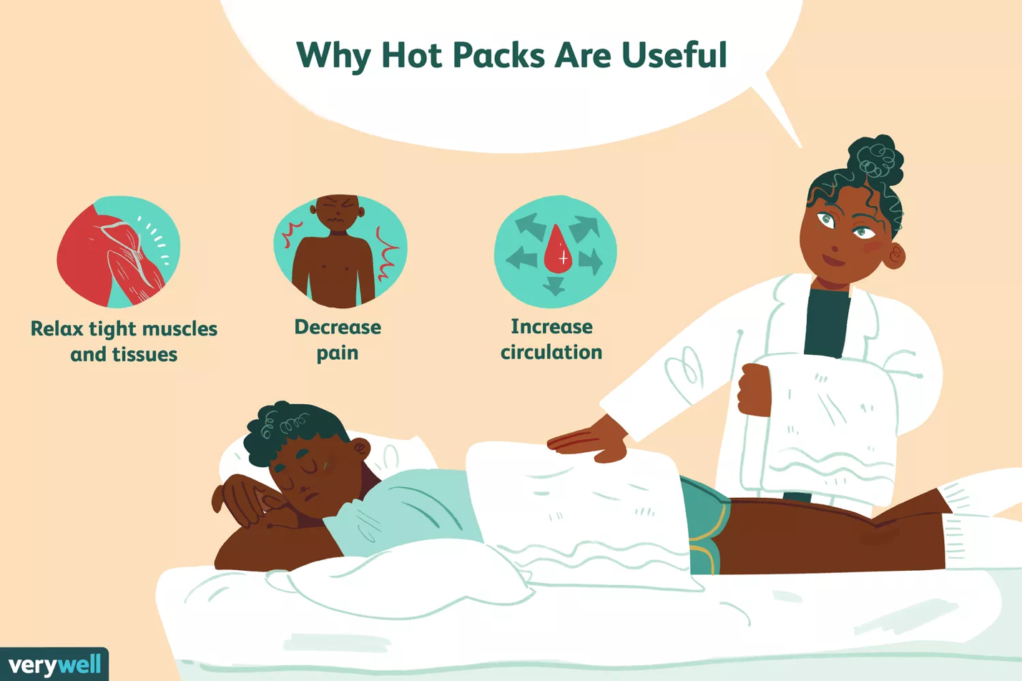

Verywell / Emily Roberts

Benefits of Hot Packs

The heat provided by hot packs has several important benefits. These may include:1﻿﻿

* Relaxes tight muscles, causing tissues to relax.
* Decreases pain caused by muscle tension or spasms.
* Causes vasodilatation of the blood vessels, which increases circulation to the area.

Increased circulation to your injured body part helps bring in nutrients, oxygen, and cells that promote healing. This increased circulation can also wash away metabolic waste materials that may be gathered around your injured body site.

Who Benefits From Using Hot Packs?

Patients with certain conditions typically benefit from using hot packs in the physical therapy clinic. These conditions may include:

* Arthritis
* Chronic pain
* Joint contracture
* Muscle spasms
* Chronic injury where increased blood flow is desired

After an injury, heat helps to increase tissue extensibility and improve the way your muscles move.1﻿﻿

How Is Heat Applied?

If your PT chooses to apply heat to your body part during your PT sessions, it can be helpful to know how that process happens. That way, you'll be prepared if you use heat in PT. Heat is applied in specific ways:

1. Your body should be positioned comfortably
2. The body part to be treated with heat should be exposed
3. Your PT will obtain a hot pack from a device called a hydrocollator. This is a big box containing water heated to about 160 degrees. The hot pack is filled with clay and sand, and it absorbs the hot water.
4. The hot pack is wrapped in a terry cloth towel and applied to your body part to be treated.

When the heat is first applied, it may not feel hot; it takes a few minutes for the heat to penetrate the toweling. Just wait a few minutes and you'll start feeling the heat penetrate your skin.

Who Should Avoid Using Hot Packs?

There are certain conditions where using moist heat and hot packs should be avoided. These may include:

* In areas of impaired or altered sensitivity (like having numbness or tingling)
* In people with impaired mental capacity
* Over open wounds
* After acute injury
* Over joints with acute [hemarthrosis](https://www.verywellhealth.com/hemarthrosis-what-you-need-to-know-2552219)
* In persons with multiple sclerosis who are sensitive to heat

If you have an injury and are considering using heat, you should check in with your healthcare provider to ensure that using hot packs is a safe thing for you to do. A visit to your physical therapist can help determine if you should be using heat.

How Long Should Heat Be Used?

Heat and hot packs are often applied to your body for 10 to 15 minutes. Frequent checks should be made to ensure that you are not getting too hot and to avoid skin damage. If you are getting too warm, you must remove the hot pack from your body. Using heat multiple times a day is not recommended, as it may damage your skin.

A Few Words of Caution

If you are going to a physical therapist, he or she may use heat to help treat your condition. Using heat on a long-term basis may not be recommended, as it may cause erythema ab igne, a condition marked by mottled and discolored skin.2﻿﻿ There is some evidence that this increases the likelihood of [skin cancer](https://www.verywellhealth.com/skin-cancer-4014650), but research is not 100% accurate on this claim.

Physical therapists are movement experts, and they should engage you in an active rehab program to improve [range of motion](https://www.verywellhealth.com/overview-range-of-motion-2696650) and strength to improve functional mobility. Hot packs are a passive modality where you are required to no nothing. This puts your overall health in the hands of your physical therapist and not in your control.

Be sure that if you use hot packs in the PT clinic, you are also engaged in exercise and active rehab. If your PT only uses passive treatments such as heat, ultrasound, or electrical stimulation, ask to be more involved in an active rehab program. If passive treatment continues, it may be [time to find a new physical therapist](https://www.verywellhealth.com/electrical-stimulation-2696122).

A Word From Verywell

If you have an injury that causes pain or limited functional mobility, you should check in with your healthcare provider and visit your physical therapist to work to get back to full function. Your PT may use modalities—like hot packs—to help augment your physical therapy program. Using hot packs can feel good and get you on the right track to full functional mobility.